**Commodore C64 WiFi-Modem PET Adapter Rev. 0  
Module Description**

The C64 WiFi-Modem Adapter for PET was made to connect the C64 WiFi-Modem (<https://1200baud.wordpress.com/2017/03/04/build-your-own-9600-baud-c64-wifi-modem-for-20/>), [(project on github.com)](https://github.com/svenpetersen1965/C64-WiFi-Modem-User-Port) to the User Port of the Commodore PET or CBM.

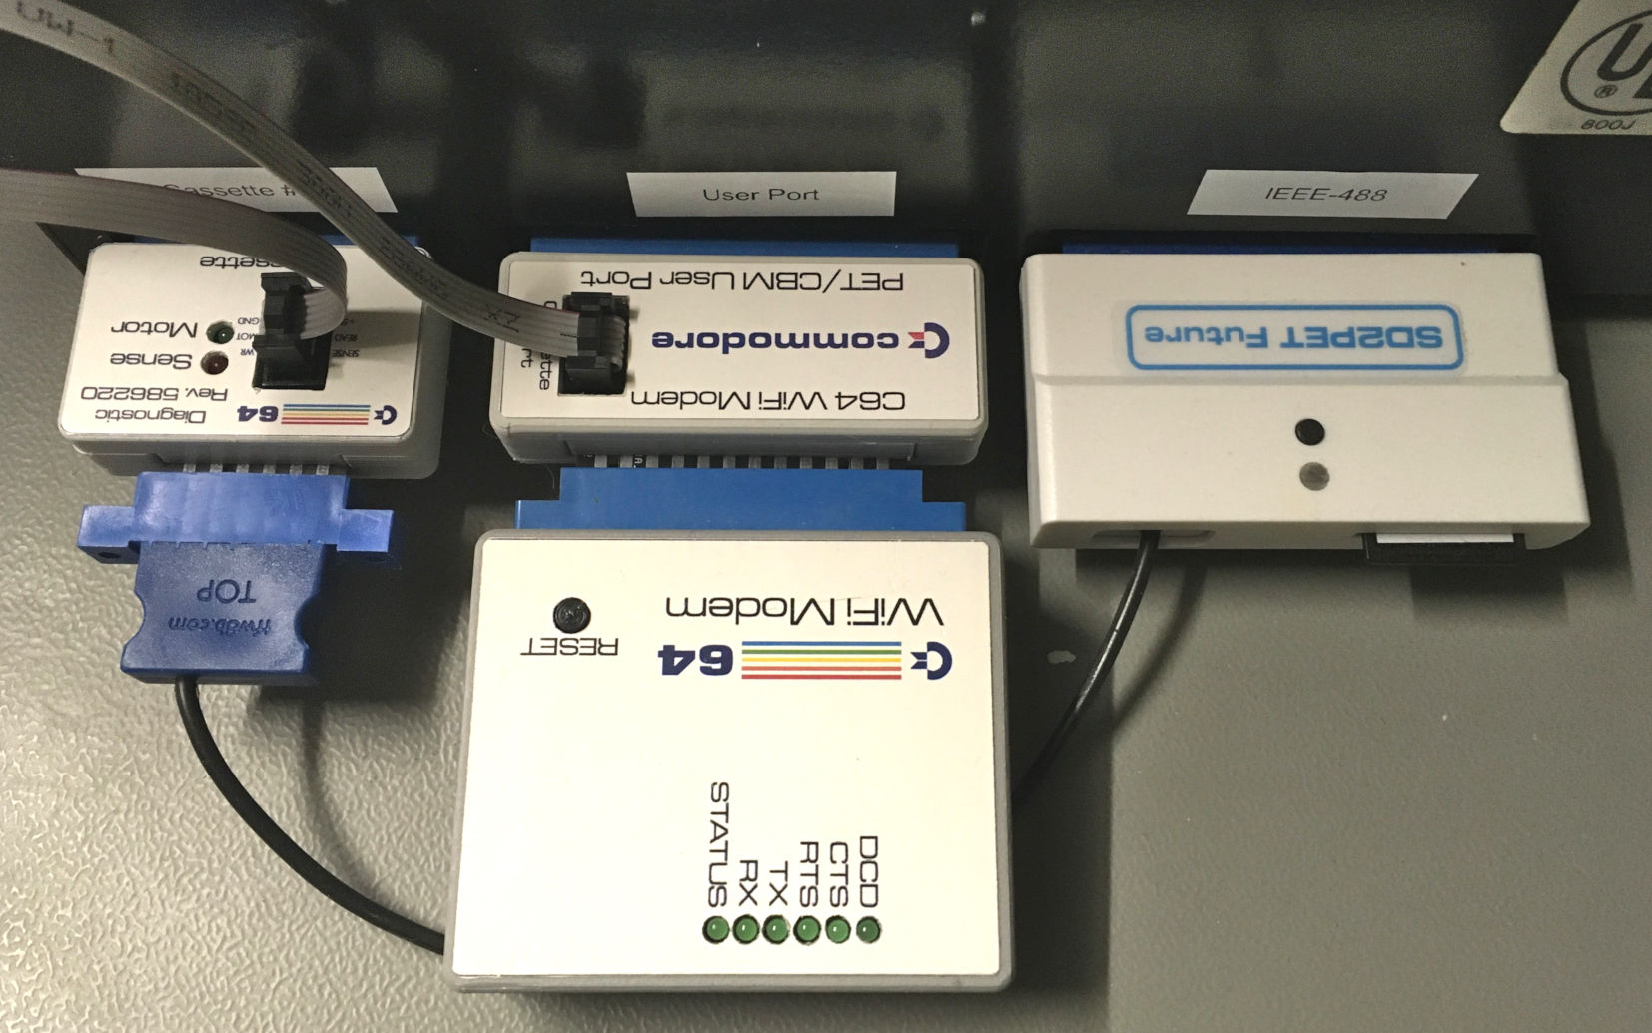

Figure 1: Setup with cassette dongle, user port adapter, WiFi modem and SD2PET

The wiring is done according to the requirements of the terminal program [PETTERM 0.5.0](https://github.com/ChartreuseK/PETTERM/releases).

|  |  |  |  |  |  |
| --- | --- | --- | --- | --- | --- |
| Modem Signal | PET User Port | Direction (seen from PET) | PET UP Pin | C64 Modem | Modem Pin |
| TxD | CA1 & PA0 | input | B & C | Flag & PB0 | B & C |
| RxD | CB2 | output | M | PA2 | M |

The signals RTS, DCD and CTS are not used, neither by the modem nor by PETTERM.

To provide an upgrade in future, the unused PET User Port pins and the signals mentioned before, are connected to a pin header (for jumpering).

|  |  |  |  |  |  |
| --- | --- | --- | --- | --- | --- |
| **Pin** | **PET Userport** | **JP1** | **JP1** | **C64 WiFi Modem** | **Pin** |
| D | PA1 | 13 | 14 | RTS | D |
| E | PA2 | 11 | 12 | - | - |
| F | PA3 | 9 | 10 | - | - |
| H | PA4 | 7 | 8 | DCD | H |
| J | PA5 | 5 | 6 | - | - |
| K | PA6 | 3 | 4 | CTS | K |
| L | PA7 | 1 | 2 | - | - |

Since the PET User Port does not provide +5V for powering the modem, this voltage is tapped from the Cassette Port and [a cassette port dongle](https://github.com/svenpetersen1965/C64-Diagnostic-Rev.-586220-Harness/tree/master/Diag586220_Harness/Diag586220_Cassette_Port), which is also used in the C64 Diagnostic Harness. The connection is achieved with a 2x3 pin header (J3) and a ribbon cable.

|  |  |  |  |
| --- | --- | --- | --- |
| **Signal** | **Pin** | **Pin** | **Signal** |
| GND | 1 | 2 | +5V |
| - | 3 | 4 | - |
| - | 5 | 6 | - |

There is also a barrel connector for the +5V (5.5/2.1mm), which is not recommended to use, since it might collide with an IEEE-488 port connector/device.

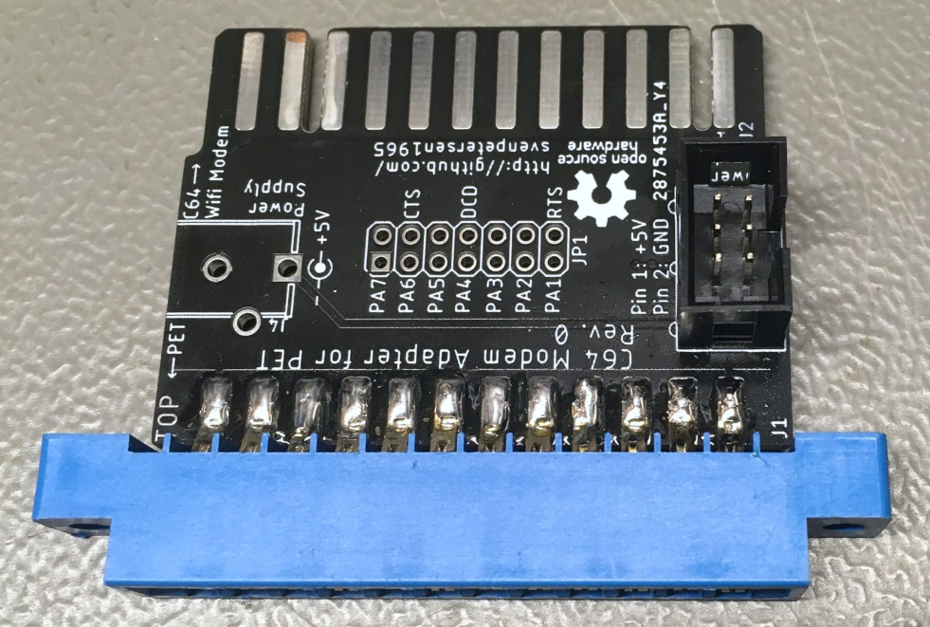

Figure 2: assembled PCB of the WiFi modem adapter

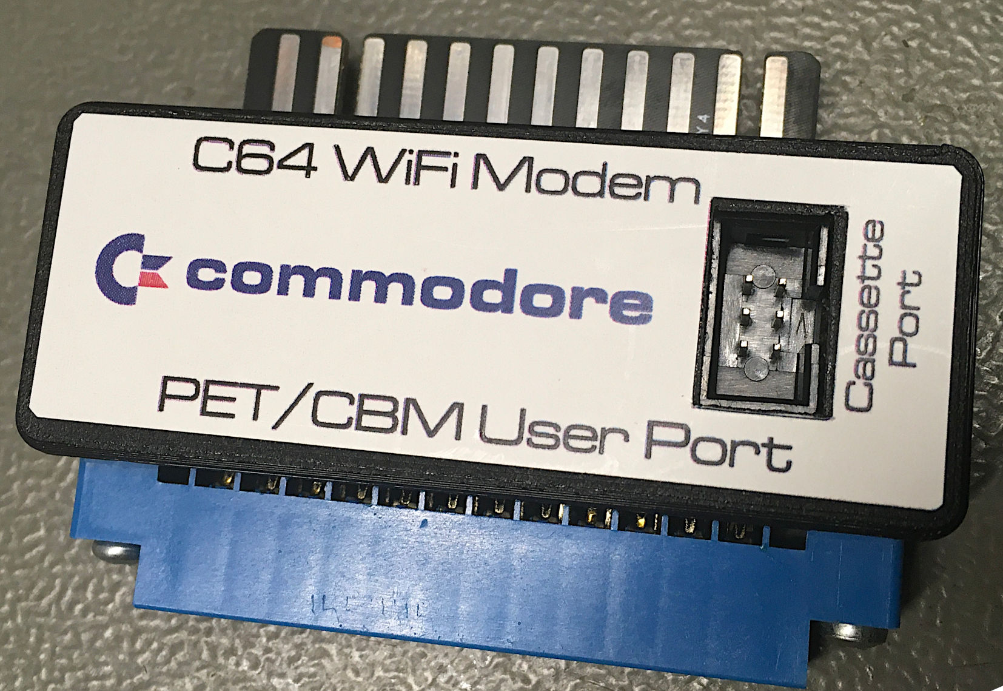

Figure 3: Adapter in 3D printed case

The screws recommended for the 3D printed case are

* 2x C2.9x9.5 DIN 7981 (for connecting bottom shell and top shell of the case)
* 2x C2.9x13 DIN 7981 (for attaching the edge connector to the bottom shell)

Other screws of approximately the same dimensions might work as well.

# Dimensions

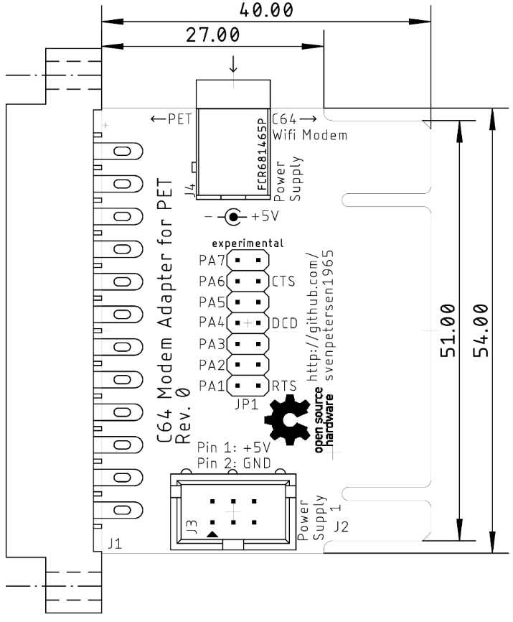

# Revision History

## Rev. 0

* Fully functional prototype